

Customize The White-Label Presentation Deck... In Minutes
Note: These instructions are specifically for Microsoft PowerPoint, but similar customization actions can be performed in Google Slides with slight menu locations and terminology variations.

As a reseller of our platform, we've created a white-label version of our capabilities presentation to assist you. You can use this presentation as is or customize it to represent your brand.

We used the Master Slide and Slide Layouts to help you add your brand in minutes.

Use This Guide To...
When you make an update or change to the Master Slide it will affect all slides in your presentation. You can also use Slide Layouts and other functions to easily update quickly. This guide includes the basics on how to:
● Add Your Logo
● Change Font, Size & Style
● Update The Footer
● Change Icon Color

Add Your Logo
- Go to View > Slide Master, select the Master Slide, and right-click the logo
- Select Change Picture...
- Find and select your logo file
(We recommend a .png with a transparent background for the best appearance)
- Click Insert
- Edits made to the Master Slide appear on all slides in the presentation. To view your changes, exit the slide master (slide master> close master OR view> normal view).

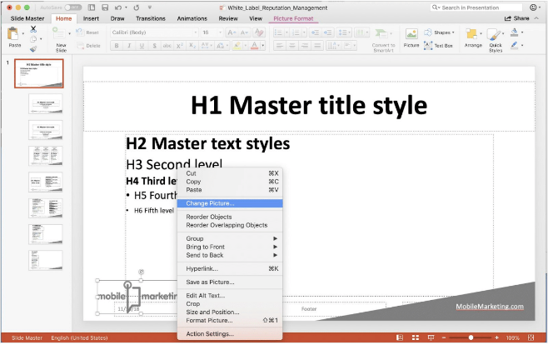

Change Font, Size & Style
The Master Slide controls all text's font, font size, and style. If you update a level of text (H1-H6) on the Master Slide, all slides in the presentation are updated instantly. It's that easy.
- Go to View > Slide Master, select the Master Slide
- Select any line of text and update the font, size, and style
- Edits made to the Master Slide appear on all slides in the presentation. Exit the Slide Master (Slide Master > Close Master OR View > Normal View) to view your changes.

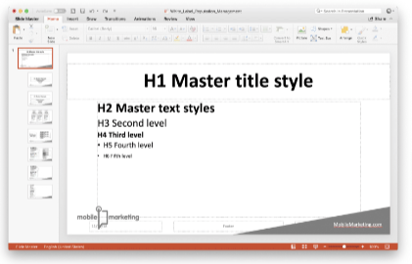

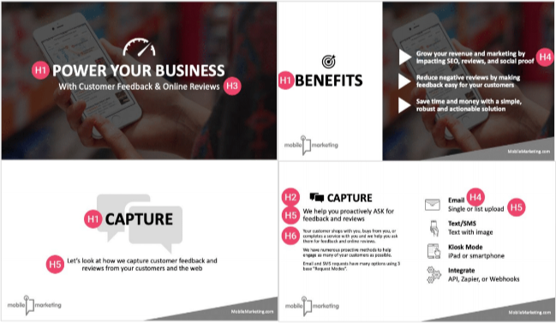

Update The Footer
Included in the footer for this presentation is a shape and text box with a website address. You can easily edit or remove these objects from the footer in the Master Slide.
- Go to View > Slide Master, select the Master Slide
- Use tools from available tabs including Home, Insert, Draw, etc. to add or edit objects on the Master Slide
- Edits made to the Master Slide appear on all slides in the presentation. Exit the Slide Master (Slide Master > Close Master OR View > Normal View) to view your changes.

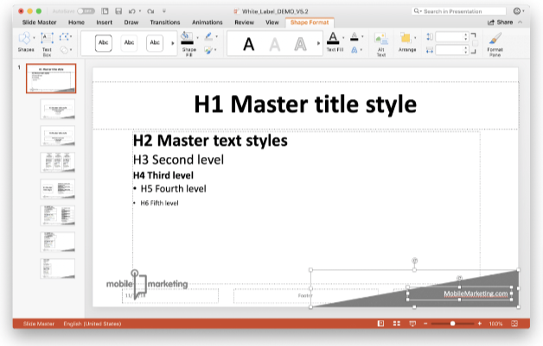

Change Icon Color
You can quickly change the color of the main icons in this presentation by adding a custom color to the Grayscale color palette.
- In the normal view (View > Normal) navigate to Design > Color Palettes Down Arrow > Colors > Customize Colors.
- Select the colored box for Text/Background - Dark 2., choose your color and click Save.

