

White-Label Reputation Management Reseller Guide

Seize the Opportunity in a Booming Market
In today's digital age, a business's online reputation is more important than ever. With the vast majority of consumers turning to online reviews and social media to inform their purchasing decisions, effective reputation management has become a critical component of success.

Studies show that 93% of consumers read online reviews before making a purchase, and 94% say that negative reviews have convinced them to avoid a business altogether.

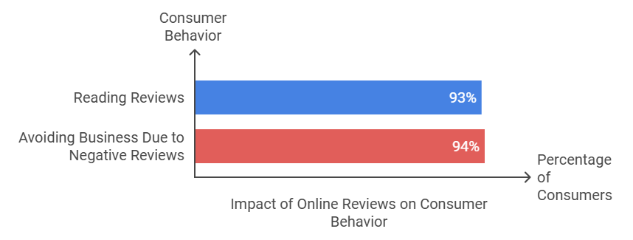

For agencies, consultants, and digital service providers, this presents a tremendous opportunity. By offering white-label reputation management services, these businesses can tap into a rapidly growing market, expand their service offerings, and generate a significant new revenue stream.

And with the right partner, they can do so without the significant investment and overhead required to develop their own technology and infrastructure.

This comprehensive guide will explore the world of white-label reputation management reselling, with a particular focus on Review Dingo's innovative platform and reseller program. We'll delve into the current state of the market, examine the key features and benefits of Review Dingo's offering, and provide practical strategies and tactics for success.

Whether you're a digital marketing agency looking to expand your services, a business consultant seeking to differentiate yourself from the competition, or an SEO specialist looking to offer more value to your clients, this guide will provide you with the knowledge and tools you need to succeed.

The Power of Online Reputation
Before we dive into the specifics of white-label reputation management reselling, let's take a moment to consider the importance of online reputation in today's digital landscape.

In a world where anyone can share their thoughts and experiences with a few clicks or taps, the way a business is perceived online can have a profound impact on its success.

Consider these statistics:
- 84% of people trust online reviews as much as personal recommendations from friends and family.
- A single negative article can drive away up to 22% of potential customers.
- A one-star increase in a business's Yelp rating can lead to a 5-9% increase in revenue.

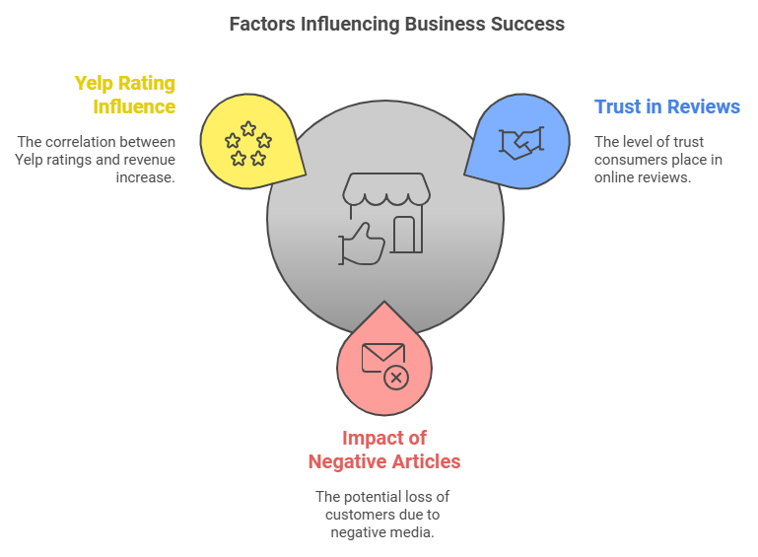

These numbers paint a clear picture: online reputation matters and businesses that fail to manage it effectively do so at their peril.

But online reputation is about more than just reviews and ratings. In today's digital trust economy, every aspect of a business's online presence contributes to its overall reputation.

From social media engagement and customer feedback to search engine rankings and brand sentiment, the way a business presents itself online can have a significant impact on its ability to attract and retain customers.

The Market Opportunity
As businesses increasingly recognize the importance of online reputation management, the demand for effective solutions has skyrocketed.

According to recent projections, the global market for feedback and reviews management software is expected to reach $26.90 billion by 2033, representing a compound annual growth rate of 17.1%.

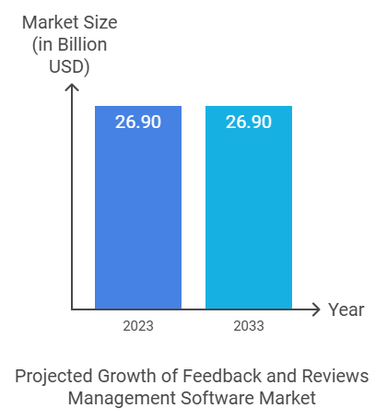

This growth is being driven by several key factors, including:
- The accelerating pace of digital transformation across industries
- The increasing importance of online customer experience and engagement
- The growing recognition among businesses of the impact of online reputation on revenue and growth

For agencies and service providers, this presents a significant opportunity. By offering reputation management services to their clients, these businesses can tap into a growing market and generate a significant new revenue stream.

With the rise of white-label solutions like Review Dingo, they can do so without the significant investment and overhead required to develop their own technology and infrastructure.

The Competitive Landscape
Of course, as with any growing market, the white-label reputation management space is becoming increasingly competitive. There are a number of players in the market, each with their own strengths and focus areas.



At the enterprise level, platforms like Birdeye, ReviewTrackers, and Reputation.com offer comprehensive solutions with a wide range of features and capabilities. However, these platforms can be complex and expensive, making them less accessible to smaller agencies and service providers.

In the mid-market, players like Podium, GatherUp, and Chatmeter offer more targeted solutions focused on specific areas like customer feedback, social media monitoring, and location-based management.

While these platforms can be effective for certain use cases, they may not provide the full range of capabilities needed for a comprehensive reputation management offering.

This is where Review Dingo stands out. With its powerful AI-driven platform, comprehensive white-label capabilities, and attractive reseller benefits, Review Dingo is uniquely positioned to help agencies and service providers succeed in the reputation management market.

Review Dingo's Reseller Program
At the heart of Review Dingo's offering is its comprehensive reseller program. Designed specifically for agencies, consultants, and digital service providers, this program provides everything a business needs to start offering reputation management services to its clients quickly and easily.

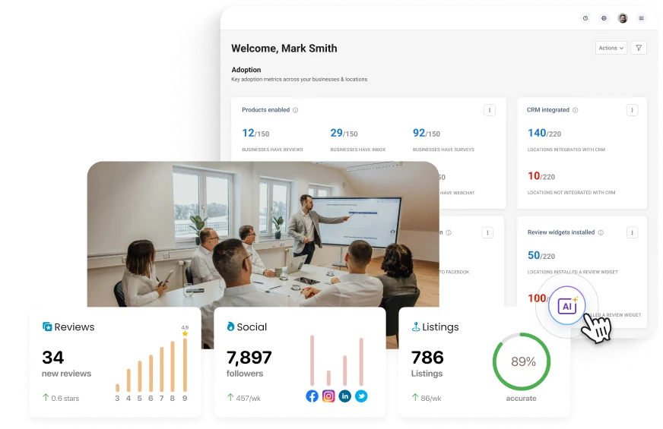

Some of the key benefits of the Review Dingo reseller program include:

- Industry-leading profit margins of 50% on all services
- No minimum purchase requirements or long-term contracts
- Complete white-label capabilities, including custom branding and domain integration
- Comprehensive training and support, including dedicated account management and ongoing education
- Performance-based bonuses and incentives to help drive growth and profitability

With Review Dingo, resellers can offer a full suite of reputation management services to their clients, including review monitoring and response, listing management, social media management, and more.

And with the platform's powerful AI capabilities and automation features, they can do so efficiently and effectively, without the need for significant additional staff or resources.

Getting Started as a Reseller
So how does a business get started as a Review Dingo reseller? The process is simple and can be broken down into a few key steps.

- Discovery Call: The first step is to schedule a discovery call with a Review Dingo representative. During this call, you'll discuss your business goals and needs, evaluate the fit with Review Dingo, and outline the onboarding process.
- Onboarding: Once you've decided to move forward, you'll complete the reseller agreement, gain access to training materials, and set up your billing and invoicing.
- Branding Integration: Next, you'll work with the Review Dingo team to customize your white-label assets, configure your domain settings, and implement any necessary brand guidelines.
- Training and Certification: To ensure your success as a reseller, Review Dingo provides comprehensive training. This includes live training sessions and self-paced modules.
- Platform Configuration: Finally, you'll work with the Review Dingo team to set up your client accounts, integrate any existing clients, and customize your notification settings.

Throughout the process, Review Dingo's dedicated support team will be there to guide you and answer any questions you may have.

Product and Service Offering
As a Review Dingo reseller, you'll have access to a full suite of reputation management services to offer your clients. Some of the key features and capabilities include:

- Review Monitoring: Real-time tracking of reviews across multiple platforms, with AI-powered sentiment analysis and keyword-based alerts.
- Review Response: AI-generated response suggestions, customizable templates, and multi-location response management, all from a single dashboard.
- Listing Management: Automated listing distribution and syncing across over 200+ online directories and platforms, including Google, Facebook, and Yelp.
- Social Media Management: Integrated social media monitoring and management, with AI-powered sentiment analysis and engagement suggestions.
- Reporting and Analytics: Customizable reporting templates, scheduled report generation, and multi-location performance tracking, all with easy-to-use dashboards.

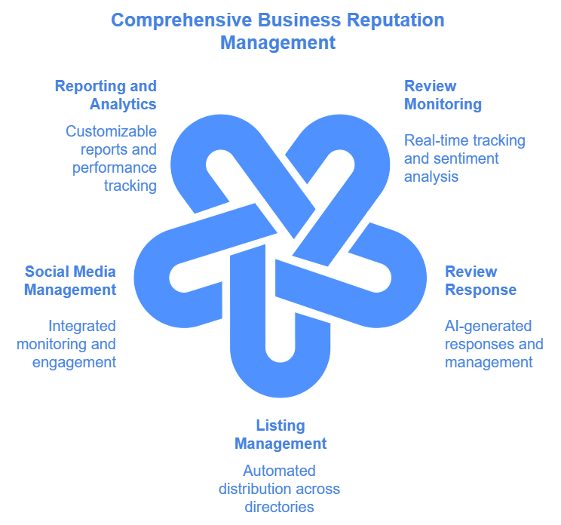

In addition to these core features, Review Dingo also offers a range of add-on services and capabilities, including social posting, listings management, and more.

Pricing and Packaging
One of the key benefits of the Review Dingo reseller program is the flexibility it provides in terms of pricing and packaging. As a reseller, you'll have complete control over how you price and package your services, with the ability to set your own margins and bundle services in a way that makes sense for your business and your clients.



Review Dingo's base pricing starts at just $100 per month per location, with a recommended reseller price of $200 per month. This provides a healthy 50% margin for resellers, with the potential for even higher margins through bundling and add-on services.

In addition, Review Dingo offers a range of performance-based bonuses and incentives to help drive growth and profitability for resellers. For example, resellers can earn a $200 bonus for every 5 new locations sold in their first 30 days.

Sales and Marketing Strategies Very
Of course, offering a great product is only half the battle. To be successful as a Review Dingo reseller, you'll also need to have effective sales and marketing strategies in place to attract and retain clients. Here are a few key strategies to consider:

- Identify Your Target Market: The first step in any effective sales and marketing strategy is to identify your target market. Who are the businesses that are most likely to benefit from reputation management services? What industries are they in? What size are they? By answering these questions, you can develop a clear picture of your ideal client and tailor your messaging and outreach accordingly.
- Develop Your Value Proposition: Once you know who your target market is, the next step is to develop a clear and compelling value proposition using your brand, experience, and product or service. What makes your reputation management services unique and valuable to your clients? How do you help them achieve their goals and overcome their challenges? By articulating your value proposition clearly and consistently, you can differentiate yourself from the competition and build trust with potential clients.

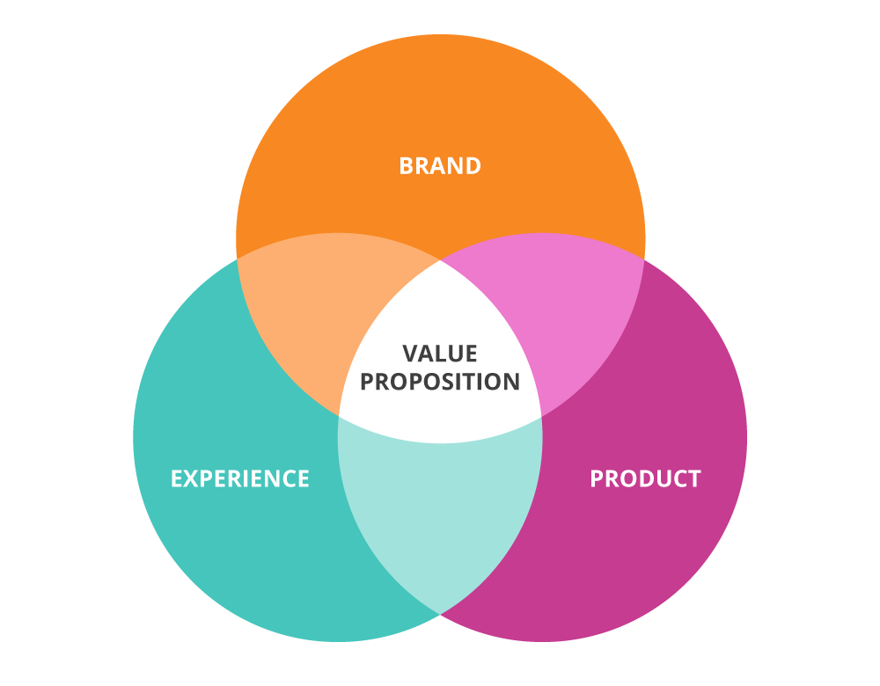

- Leverage Case Studies and Testimonials: One of the most effective ways to demonstrate the value of your services is through case studies and testimonials from satisfied clients. By showcasing real-world examples of how you've helped businesses improve their online reputation and achieve their goals, you can build credibility and trust with potential clients.
- Utilize Content Marketing: Another effective strategy for attracting and engaging potential clients is through content marketing. By creating valuable, informative content related to reputation management - such as blog posts, whitepapers, and videos - you can establish yourself as a thought leader in the industry and attract potential clients to your website and services.
- Attend Industry Events: Finally, attending industry events and conferences can be a great way to network with potential clients and partners, stay up-to-date on the latest trends and best practices, and promote your services to a targeted audience.

By implementing these sales and marketing strategies consistently and effectively, you can build a strong pipeline of potential clients and grow your reputation management business over time.

Overcoming Challenges
Of course, no business is without its challenges, and white-label reputation management reselling is no exception. Some of the common challenges that resellers face include:

- Client Expectation Management: One of the biggest challenges for reputation management resellers is managing client expectations. Many businesses have unrealistic expectations about how quickly they can see results, or what kind of impact reputation management can have on their bottom line. As a reseller, it's important to set clear, realistic expectations with clients from the outset, and to communicate regularly about progress and results.
- Demonstrating ROI: Another common challenge is demonstrating the ROI of reputation management services to clients. While the impact of reputation management can be significant, it can also be difficult to quantify and attribute directly to specific actions or initiatives. As a reseller, it's important to have clear metrics and reporting in place to help demonstrate the value of your services to clients.
- Differentiation in a Crowded Market: As the reputation management market becomes more crowded, it can be challenging for resellers to differentiate themselves and stand out from the competition. This is where having a clear value proposition and unique offering can be crucial. By focusing on specific industries, providing exceptional customer service, or offering additional value-added services, resellers can set themselves apart and attract clients looking for a more tailored solution.
- Technical Challenges: Finally, resellers may face technical challenges related to integrating Review Dingo's platform with their clients' existing systems and processes. While Review Dingo provides comprehensive support and training to help resellers overcome these challenges, it's important to have a basic understanding of the technical requirements and to set clear expectations with clients around integration and setup.

By being aware of these common challenges and having strategies in place to address them proactively, resellers can position themselves for success and build strong, long-lasting relationships with their clients.

Conclusion
White-label reputation management reselling presents a significant opportunity for agencies, consultants, and digital service providers looking to expand their offerings and tap into a growing market.

With the right partner and the right strategies in place, resellers can quickly and easily start offering reputation management services to their clients, generating a significant new revenue stream and providing tremendous value to their clients.

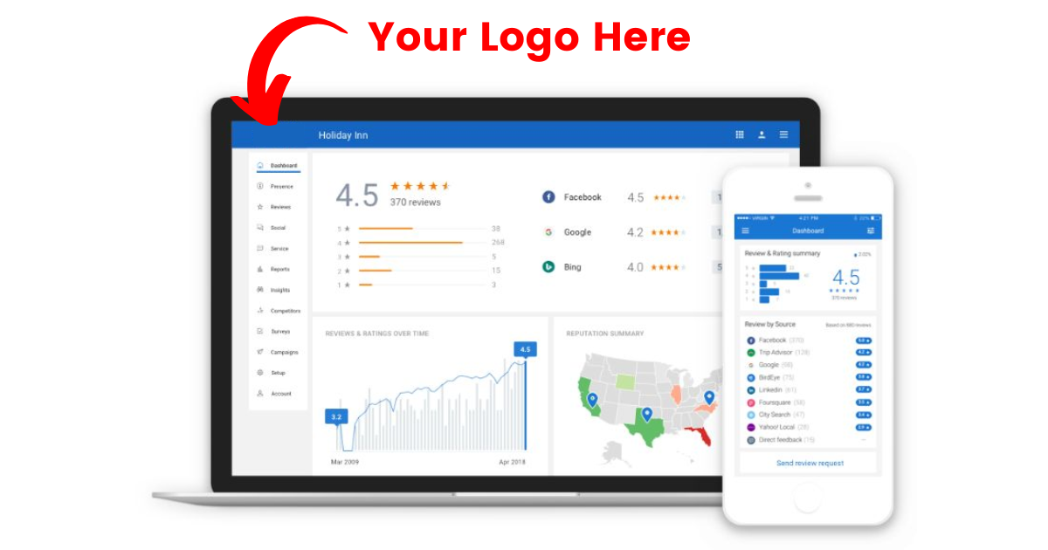

Review Dingo's comprehensive reseller program and powerful AI-driven platform make it an ideal choice for businesses looking to enter the reputation management market. With industry-leading profit margins, complete white-label capabilities, and comprehensive training and support, Review Dingo provides everything resellers need to succeed.

Of course, success as a reseller requires more than just a great product. It requires a clear understanding of the market, a compelling value proposition, effective sales and marketing strategies, and the ability to overcome common challenges and obstacles.

By following the strategies and best practices outlined in this guide, and by partnering with a trusted and experienced provider like Review Dingo, businesses can position themselves for success in the exciting and rapidly growing world of white-label reputation management reselling.

